

DSC 5101 ANALYTICS IN MANAGERIAL ECONOMICS

Group Project 1

Estimation of Coffee Demand and Supply Functions

WANG XINRUI (Student ID: A0186103M, Email: xinrui.wang@u.nus.edu)

REN JIEWEN (Student ID: A0186102N, Email: jiewen.ren@u.nus.edu)

ZHANG AO (Student ID: A0176595L, Email: e0232199@u.nus.edu)

LI LIPING (Student ID: A0186040M, Email: liping.li@u.nus.edu)

# **1.Introduction**

# The objective of this project is to estimate demand and supply functions of coffee based on coffee consumption and production data from the Dutch market. Mathematical models such as Ordinary Least Square (OLS) regression and Two Stage Least Square (TSLS) regression were applied with the dataset provided.

# Section 2 of this report will introduce and explain the methodology of prediction. Section 3 will interpret the regression results and analyze the significance and effectiveness of selected models. Section 4 will discuss the limitations of our models.

# **2. Methodology**

## 2.1 Choice of Models

To estimate the demand and supply functions of coffee, we assume logarithm linearity for the variables in functions and apply the logarithmic form to OLS regression.

* Demand Function:
* Supply Function:

## Simple Ordinary Least Squares (OLS) regression model was first applied to see the association between consumption of roasted coffee and its price using log-transformed values of quantity and price. Followed by OLS regression with control variables. The third model applied was the Two-Stage-Least-Squares (TSLS) regression, to eliminate the endogeneity problem existing in the previous 2 models.

## 2.2 Choice of Variables

We discounted prices by price index to get rid of inflation impact and converted variables into their logarithmic form for interpreting the parameters as elasticity. Refer to Appendix A step 1.

The following are the **key assumptions** for the regressions**:**

1. Coffee market is in equilibrium ()
2. Endogeneity of price: consumption and coffee price are determined at the same time. Unobserved factors that increase demand will tend to increase the price as the equilibrium moves up the supply curve

2.2.1 OLS Regression

By analyzing variables provided in the dataset, below demand and supply functions were derived for OLS regression:

* Demand Function:
* Supply Function:

For the demand function, **ln_incom** is chosen as a control variable in the demand function. The presumption is that with a larger income, consumers tend to pay a higher price for coffee, but income is not determined by the coffee market, therefore it's an exogenous variable. **ln_tprice** is a valid control variable as tea is a substitute of coffee, if tprice decreases, the demand for coffee tends to fall. As tea price is not determined by the coffee market, it's exogenous. **q1, q2, q3** are season dummies, representing seasonal fluctuations, for example, length of daytime, that affect the coffee demand. We will only introduce three dummies into our model to control the impact of seasonality, since q1, q2 and q3 are relative to the baseline of q4, and the default quarter is q4.

For the supply function, we chose ln_wprice, ln_bprice, q1, q2, q3 as control variables. We included **ln_wprice**, **ln_bprice** because with higher production costs, producers tend to produce less coffee. Since raw material and labor cost are not determined by the coffee market, they are exogenous variables. With similar reasons stated above, q1, q2, q3 are exogenous variables as well. Summary statistics of variables are in Appendix C.

2.2.2 TSLS Regression

Based on the 2 key assumptions stated above, and the error term are correlated since unobserved factors that increase demand will tend to increase the price as the equilibrium moves up the supply curve. Working with the above demand and supply equation, we will have in a **reduced form**:

For **Demand function**, (price of labor per man hours) and (price of coffee beans per kg) are selected as instrumental variables (IV). The presumption is that with a higher and , price of coffee tends to increase, but that the production cost is not determined by the coffee market, therefore they are uncorrelated with coffee demand. For **Supply function**, (income per capita in current guilders) is selected as instrumental variables (IV). As coffee is not an inferior good, we assume that if income increases, the consumption of customers will increase, and product price will increase eventually. The income of customers is also uncorrelated with the coffee market.

In **First stage of regression,** we will predict by using OLS on the reduced form, the predicted price will be independent from error term by construction. For the **Second stage of regression,** we will use predicted and perform the second OLS for .

# **3. Result Interpretation**

## 3.1 Demand Function

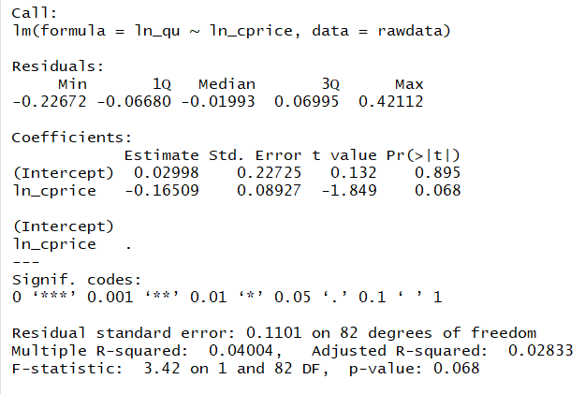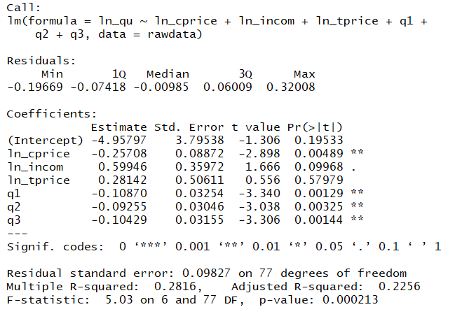For model 1 (OLS regression between consumption and prices) and model 2 (OLS regression with control variables), results are shown below:

There is a significant change in the coefficient of after adding control variables in the model 2. Because part of the negative association between demand and price is offset by income, tea price and seasonality, the coefficient in the Demand model 1 would increase. The coefficient of ln_cprice means demand will decrease 0.257% when cprice increases 1%. R-squared is also higher, which means adding extra control variables improve fits of the model. Compared with model 1, results improved but the model still has an endogeneity problem.

Combinations of quantity and price that we observe reflect the forces on both demand and supply. Therefore, the relationship we estimate is a mix of shifting demand and supply curves. To deal with this endogeneity problem we will estimate the demand equation using IV by a procedure called two-stage least squares (TSLS). In addition, we can see that tprice has p-value of 0.57979, indicating there are strong evidences suggesting that is not correlated with coffee demand. Therefore, we should eliminate tprice from our model.

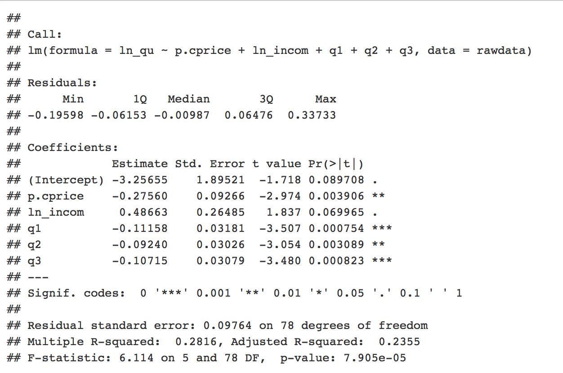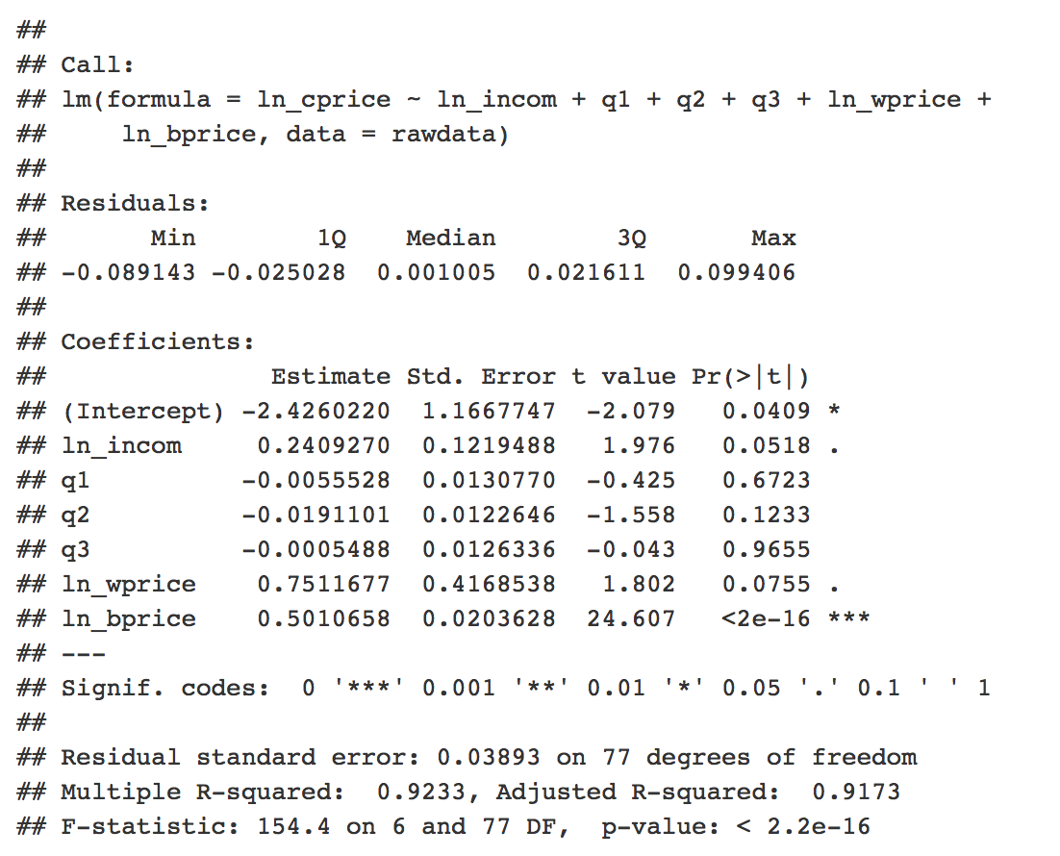Model 3: Two Stage Least Squares (TSLS) regression (refer to Appendix A step 4)

Refer to Appendix A step 5 and 6, we have a p-value of 0.001385 for Hausman Test and a p-value of 0.73306 for Sargan Test. We therefore reject the null hypothesis in the Hausman Test, which indicates there is no endogeneity between our IV and the residuals. Since p value for Sargan test is significantly greater than 0.05, we can conclude that our instruments are valid.

Comparing results from model 2 and 3, we can see that R-squared improves to 0.2355 and standard errors reduce in model 3. Since it solves the ’s endogeneity problem, the TSLS is chosen as the final demand model:

The elasticity of coffee is -0.2756, implying that the consumption of coffee is relatively inelastic. The level of consumer income has a positive impact of the consumption of coffee, indicating that coffee is a normal good. In addition, since the coefficients are negative for q1, q2 and q3, we can conclude that more coffee is consumed in quarter 4. We have also conducted the test the robustness for the TSLS model. We have also conducted the test the robustness for the TSLS model (refer to Appendix B). The robust standard errors above are modified by White heteroscedasticity correction and they do not deviate much from our previous model. It seems there are not serious “thick tail” problem and coefficient estimations are efficient. So we conclude that the model is robust.

## 3.2 Supply Function

In this session, we intend to identify the supply function. The procedures of processing data are the same with the demand function. Please Refer to Appendix A step 7 and 8.

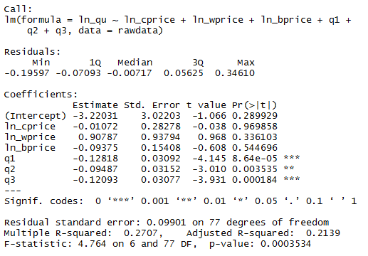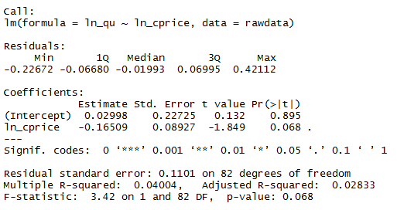First, we will do a simple OLS regression with the only price on quantity to see the relationship between them.

Compare the two OLS results above, the adjusted R-squared has improved from 0.02833 to 0.2139, so the latter model estimates the supply curve better. We can conclude that, and seasonality play a role in this model. Although result improves, the model still has an endogeneity problem, as reasons suggested above. And the coefficient of ln_cprice shows that when cprice increase 1%, the production of coffee will decrease 0.01%, which is inconsistent with the normal coffee market. The negative coefficient of ln_cprice also proved that our model has an endogeneity problem.

Next, we will use income (income per capita in current guilders) as instruments to do the 2SLS regression to fitting the supply curve. The results are as below.

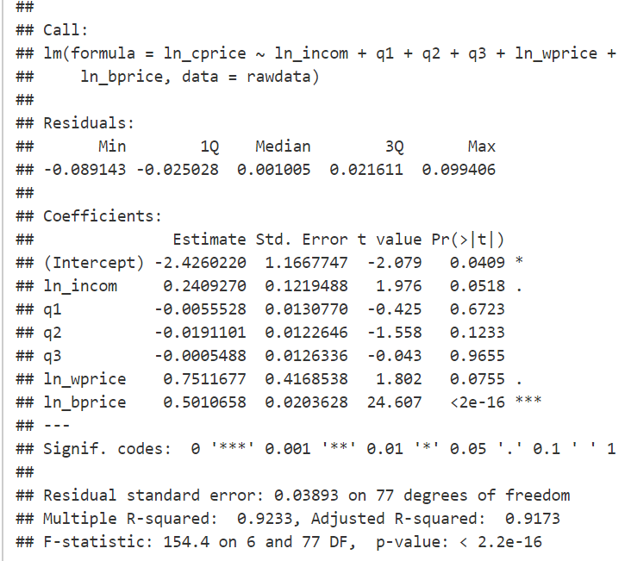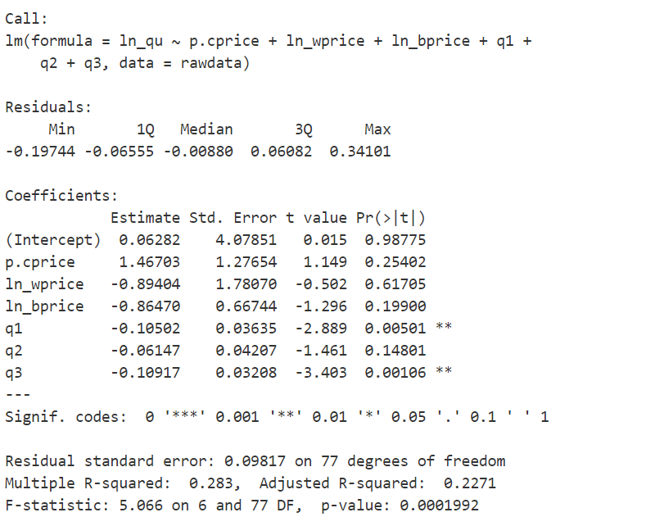

Refer to Appendix A step 10, we have a p-value of 1.125e-32 for Hausman Test. Therefore, we reject the null hypothesis in the Hausman Test, which indicates there is no endogeneity between our IV and the residuals. We can conclude that our instruments are valid. And according to results of supply2.lm and 2sls, we can see that R-squared improves to 0.2271 and standard errors reduce in model 3. Thus, we chose 2SLS as the final supply model. The final supply function derived from 2SLS is shown as below:

The elasticity of coffee is 1.4670, implying that the production of coffee is significantly elastic. The wprice and bprice impacts production of coffee negatively, which is the normal case in supply market. Since the coefficients are negative for , and , we can conclude that more coffee is produced in quarter 4. We have also conducted the test the robustness for the TSLS model and conclude that the model is robust (refer to Appendix B).

# **4. Limitations**

The dataset we built our models on only contains 84 data points. Data used for prediction might not be representative of the actual coffee market. Besides, there is a lack of knowledge of the coffee market structure. From the dataset given, we are not able to find out whether the coffee market in Dutch is in perfect competition, whether it is an oligopoly market or a monopoly market. Therefore, we could only develop our models under the assumption that coffee market is in equilibrium and price of coffee is endogenous. Dutch is renowned as merchants and almost two-thirds of the economy is based on foreign trade, however external impacts from tariff and quota are not considered in the model. There might be some external forces that drive up or down the coffee price, but they are not measurable base on the information we have.

### Appendix A

**Estimation of Coffee Demand and Supply in Dutch**

30 August 2018

#### Step 1: Data Cleaning

#Read data  
rawdata = read.csv("Project1Data.csv",header=T)  
  
#Check data  
head(rawdata)

## maand year month qu cprice tprice oprice incom q1 q2 q3 q4 bprice  
## 1 Jan 1990 1990 1 0.55 12.12 18.6 1 1640.87 1 0 0 0 3.47  
## 2 Feb 1990 1990 2 0.65 12.12 18.6 1 1538.60 1 0 0 0 3.40  
## 3 Mar 1990 1990 3 0.66 12.12 18.6 1 1680.93 1 0 0 0 3.26  
## 4 Apr 1990 1990 4 0.66 12.12 18.6 1 1656.20 0 1 0 0 3.46  
## 5 May 1990 1990 5 0.64 12.12 18.6 1 1700.80 0 1 0 0 3.47  
## 6 Jun 1990 1990 6 0.65 12.12 18.6 1 1732.67 0 1 0 0 3.68  
## wprice  
## 1 28.15  
## 2 28.15  
## 3 28.33  
## 4 28.49  
## 5 28.55  
## 6 28.55

tail(rawdata)

## maand year month qu cprice tprice oprice incom q1 q2 q3 q4  
## 79 Jul 1996 1996 7 0.64 15.63 19.53 1.17 2238.07 0 0 1 0  
## 80 Aug 1996 1996 8 0.59 15.63 19.53 1.16 2224.40 0 0 1 0  
## 81 Sep 1996 1996 9 0.74 15.63 19.53 1.17 2164.13 0 0 1 0  
## 82 Oct 1996 1996 10 0.74 15.63 19.34 1.18 2238.53 0 0 0 1  
## 83 Nov 1996 1996 11 0.72 15.39 20.09 1.18 2211.87 0 0 0 1  
## 84 Dec 1996 1996 12 0.83 15.15 20.27 1.18 2297.20 0 0 0 1  
## bprice wprice  
## 79 4.77 34.15  
## 80 4.64 34.15  
## 81 4.65 34.15  
## 82 4.59 34.21  
## 83 4.47 34.21  
## 84 4.41 34.18

#Adjustment for Inflation  
rawdata$cprice <- rawdata$cprice/rawdata$oprice  
rawdata$tprice <- rawdata$tprice/rawdata$oprice  
rawdata$bprice <- rawdata$bprice/rawdata$oprice  
rawdata$wprice <- rawdata$wprice/rawdata$oprice  
rawdata$incom <- rawdata$incom/rawdata$oprice  
  
#Construction of variables in logs  
rawdata$ln_qu <- log(rawdata$qu)  
rawdata$ln_cprice <- log(rawdata$cprice)  
rawdata$ln_tprice <- log(rawdata$tprice)  
rawdata$ln_incom <- log(rawdata$incom)  
rawdata$ln_bprice <- log(rawdata$bprice)  
rawdata$ln_wprice <- log(rawdata$wprice)  
  
#Plot data  
library(ggplot2)  
ggplot(rawdata,aes(ln_qu, ln_cprice)) + geom_point() + geom_smooth(method = "lm")

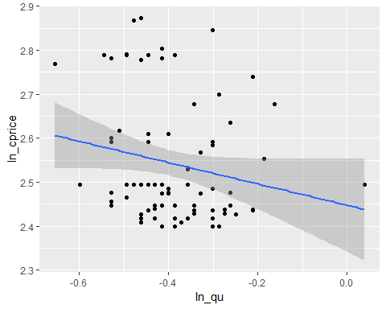

#### Step 2: OLS regression between consumption and prices

demand1.lm <- lm(ln_qu ~ ln_cprice,data=rawdata)  
summary(demand1.lm)

##   
## Call:  
## lm(formula = ln_qu ~ ln_cprice, data = rawdata)  
##   
## Residuals:  
## Min 1Q Median 3Q Max   
## -0.22672 -0.06680 -0.01993 0.06995 0.42112   
##   
## Coefficients:  
## Estimate Std. Error t value Pr(>|t|)   
## (Intercept) 0.02998 0.22725 0.132 0.895   
## ln_cprice -0.16509 0.08927 -1.849 0.068 .  
## ---  
## Signif. codes: 0 '***' 0.001 '**' 0.01 '*' 0.05 '.' 0.1 ' ' 1  
##   
## Residual standard error: 0.1101 on 82 degrees of freedom  
## Multiple R-squared: 0.04004, Adjusted R-squared: 0.02833   
## F-statistic: 3.42 on 1 and 82 DF, p-value: 0.068

#### Step 3: OLS regression with other control variables

demand2.lm <- lm(ln_qu ~ ln_cprice + ln_incom + ln_tprice + q1 + q2 + q3,data=rawdata )  
summary(demand2.lm)

##   
## Call:  
## lm(formula = ln_qu ~ ln_cprice + ln_incom + ln_tprice + q1 +   
## q2 + q3, data = rawdata)  
##   
## Residuals:  
## Min 1Q Median 3Q Max   
## -0.19669 -0.07418 -0.00985 0.06009 0.32008   
##   
## Coefficients:  
## Estimate Std. Error t value Pr(>|t|)   
## (Intercept) -4.95797 3.79538 -1.306 0.19533   
## ln_cprice -0.25708 0.08872 -2.898 0.00489 **  
## ln_incom 0.59946 0.35972 1.666 0.09968 .   
## ln_tprice 0.28142 0.50611 0.556 0.57979   
## q1 -0.10870 0.03254 -3.340 0.00129 **  
## q2 -0.09255 0.03046 -3.038 0.00325 **  
## q3 -0.10429 0.03155 -3.306 0.00144 **  
## ---  
## Signif. codes: 0 '***' 0.001 '**' 0.01 '*' 0.05 '.' 0.1 ' ' 1  
##   
## Residual standard error: 0.09827 on 77 degrees of freedom  
## Multiple R-squared: 0.2816, Adjusted R-squared: 0.2256   
## F-statistic: 5.03 on 6 and 77 DF, p-value: 0.000213

##### Step 4: TSLS for demand

#library(AER)  
#demand.2sls.form <- ivreg(ln_qu ~ ln_cprice + ln_incom + q1 + q2 + q3| ln_incom + q1 + q2 + q3 + ln_bprice + ln_wprice, data=rawdata)  
#summary(demand.2sls.form, diagnostics = TRUE)  
  
#Run 2SLS on ln_cprice  
cprice.reduced.form <- lm(ln_cprice ~ ln_incom + q1 + q2 + q3 + ln_wprice + ln_bprice,data=rawdata)  
summary(cprice.reduced.form)

##   
## Call:  
## lm(formula = ln_cprice ~ ln_incom + q1 + q2 + q3 + ln_wprice +   
## ln_bprice, data = rawdata)  
##   
## Residuals:  
## Min 1Q Median 3Q Max   
## -0.089143 -0.025028 0.001005 0.021611 0.099406   
##   
## Coefficients:  
## Estimate Std. Error t value Pr(>|t|)   
## (Intercept) -2.4260220 1.1667747 -2.079 0.0409 *   
## ln_incom 0.2409270 0.1219488 1.976 0.0518 .   
## q1 -0.0055528 0.0130770 -0.425 0.6723   
## q2 -0.0191101 0.0122646 -1.558 0.1233   
## q3 -0.0005488 0.0126336 -0.043 0.9655   
## ln_wprice 0.7511677 0.4168538 1.802 0.0755 .   
## ln_bprice 0.5010658 0.0203628 24.607 <2e-16 ***  
## ---  
## Signif. codes: 0 '***' 0.001 '**' 0.01 '*' 0.05 '.' 0.1 ' ' 1  
##   
## Residual standard error: 0.03893 on 77 degrees of freedom  
## Multiple R-squared: 0.9233, Adjusted R-squared: 0.9173   
## F-statistic: 154.4 on 6 and 77 DF, p-value: < 2.2e-16

p.cprice= predict(cprice.reduced.form)  
struc.2sls.form <- lm(ln_qu ~ p.cprice + ln_incom + q1 + q2 + q3,data=rawdata )  
summary(struc.2sls.form)

##   
## Call:  
## lm(formula = ln_qu ~ p.cprice + ln_incom + q1 + q2 + q3, data = rawdata)  
##   
## Residuals:  
## Min 1Q Median 3Q Max   
## -0.19598 -0.06153 -0.00987 0.06476 0.33733   
##   
## Coefficients:  
## Estimate Std. Error t value Pr(>|t|)   
## (Intercept) -3.25655 1.89521 -1.718 0.089708 .   
## p.cprice -0.27560 0.09266 -2.974 0.003906 **   
## ln_incom 0.48663 0.26485 1.837 0.069965 .   
## q1 -0.11158 0.03181 -3.507 0.000754 ***  
## q2 -0.09240 0.03026 -3.054 0.003089 **   
## q3 -0.10715 0.03079 -3.480 0.000823 ***  
## ---  
## Signif. codes: 0 '***' 0.001 '**' 0.01 '*' 0.05 '.' 0.1 ' ' 1  
##   
## Residual standard error: 0.09764 on 78 degrees of freedom  
## Multiple R-squared: 0.2816, Adjusted R-squared: 0.2355   
## F-statistic: 6.114 on 5 and 78 DF, p-value: 7.905e-05

#### Step 5: Hausman test for demand

hausman_test <- lm(struc.2sls.form$residuals ~ ln_wprice + ln_bprice,data=rawdata)  
summary(hausman_test)

##   
## Call:  
## lm(formula = struc.2sls.form$residuals ~ ln_wprice + ln_bprice,   
## data = rawdata)  
##   
## Residuals:  
## Min 1Q Median 3Q Max   
## -0.19789 -0.06576 -0.00895 0.06149 0.34062   
##   
## Coefficients:  
## Estimate Std. Error t value Pr(>|t|)  
## (Intercept) -0.943650 2.828266 -0.334 0.740  
## ln_wprice 0.278700 0.833978 0.334 0.739  
## ln_bprice 0.002705 0.042912 0.063 0.950  
##   
## Residual standard error: 0.09575 on 81 degrees of freedom  
## Multiple R-squared: 0.001385, Adjusted R-squared: -0.02327   
## F-statistic: 0.05616 on 2 and 81 DF, p-value: 0.9454

print(summary(hausman_test)$r.squared)

## [1] 0.00138477

#### Step 6: Sargan Test for demand

p.demand.qu <- predict(struc.2sls.form,rawdata)  
head(p.demand.qu)

## 1 2 3 4 5 6   
## -0.4498000 -0.4740290 -0.4323626 -0.4250678 -0.4147352 -0.4150478

rawdata$qu_error_demand <- rawdata$ln_qu - p.demand.qu  
sargan_test_demand <- lm(qu_error_demand ~ ln_bprice +ln_wprice,data = rawdata)  
summary(sargan_test_demand)

##   
## Call:  
## lm(formula = qu_error_demand ~ ln_bprice + ln_wprice, data = rawdata)  
##   
## Residuals:  
## Min 1Q Median 3Q Max   
## -0.19789 -0.06576 -0.00895 0.06149 0.34062   
##   
## Coefficients:  
## Estimate Std. Error t value Pr(>|t|)  
## (Intercept) -0.943650 2.828266 -0.334 0.740  
## ln_bprice 0.002705 0.042912 0.063 0.950  
## ln_wprice 0.278700 0.833978 0.334 0.739  
##   
## Residual standard error: 0.09575 on 81 degrees of freedom  
## Multiple R-squared: 0.001385, Adjusted R-squared: -0.02327   
## F-statistic: 0.05616 on 2 and 81 DF, p-value: 0.9454

sargan_demand_stat = summary(sargan_test_demand)$r.squared * nrow(rawdata)  
sargan_demand_pvalue = pchisq(sargan_demand_stat, 1, lower.tail = FALSE)  
print(sargan_demand_pvalue)

## [1] 0.7330598

#### Step 7: OLS regression between supply and price

#Naive Supply Function Estimation  
supply1.lm <- lm(ln_qu ~ ln_cprice,data=rawdata)  
summary(supply1.lm)

##   
## Call:  
## lm(formula = ln_qu ~ ln_cprice, data = rawdata)  
##   
## Residuals:  
## Min 1Q Median 3Q Max   
## -0.22672 -0.06680 -0.01993 0.06995 0.42112   
##   
## Coefficients:  
## Estimate Std. Error t value Pr(>|t|)   
## (Intercept) 0.02998 0.22725 0.132 0.895   
## ln_cprice -0.16509 0.08927 -1.849 0.068 .  
## ---  
## Signif. codes: 0 '***' 0.001 '**' 0.01 '*' 0.05 '.' 0.1 ' ' 1  
##   
## Residual standard error: 0.1101 on 82 degrees of freedom  
## Multiple R-squared: 0.04004, Adjusted R-squared: 0.02833   
## F-statistic: 3.42 on 1 and 82 DF, p-value: 0.068

#### Step 8: OLS regression with other control variables

#Supply Function OLS Estimation   
supply2.lm <- lm(ln_qu ~ ln_cprice + ln_wprice + ln_bprice + q1 + q2 + q3,data=rawdata)  
summary(supply2.lm)

##   
## Call:  
## lm(formula = ln_qu ~ ln_cprice + ln_wprice + ln_bprice + q1 +   
## q2 + q3, data = rawdata)  
##   
## Residuals:  
## Min 1Q Median 3Q Max   
## -0.19597 -0.07093 -0.00717 0.05625 0.34610   
##   
## Coefficients:  
## Estimate Std. Error t value Pr(>|t|)   
## (Intercept) -3.22031 3.02203 -1.066 0.289929   
## ln_cprice -0.01072 0.28278 -0.038 0.969858   
## ln_wprice 0.90787 0.93794 0.968 0.336103   
## ln_bprice -0.09375 0.15408 -0.608 0.544696   
## q1 -0.12818 0.03092 -4.145 8.64e-05 ***  
## q2 -0.09487 0.03152 -3.010 0.003535 **   
## q3 -0.12093 0.03077 -3.931 0.000184 ***  
## ---  
## Signif. codes: 0 '***' 0.001 '**' 0.01 '*' 0.05 '.' 0.1 ' ' 1  
##   
## Residual standard error: 0.09901 on 77 degrees of freedom  
## Multiple R-squared: 0.2707, Adjusted R-squared: 0.2139   
## F-statistic: 4.764 on 6 and 77 DF, p-value: 0.0003534

##### Step 9: TSLS for supply

#Run 2SLS on ln_cprice  
cprice.reduced.form2 <- lm(ln_cprice ~ ln_incom + q1 + q2 + q3 + ln_wprice + ln_bprice,data=rawdata)  
summary(cprice.reduced.form2)

##   
## Call:  
## lm(formula = ln_cprice ~ ln_incom + q1 + q2 + q3 + ln_wprice +   
## ln_bprice, data = rawdata)  
##   
## Residuals:  
## Min 1Q Median 3Q Max   
## -0.089143 -0.025028 0.001005 0.021611 0.099406   
##   
## Coefficients:  
## Estimate Std. Error t value Pr(>|t|)   
## (Intercept) -2.4260220 1.1667747 -2.079 0.0409 *   
## ln_incom 0.2409270 0.1219488 1.976 0.0518 .   
## q1 -0.0055528 0.0130770 -0.425 0.6723   
## q2 -0.0191101 0.0122646 -1.558 0.1233   
## q3 -0.0005488 0.0126336 -0.043 0.9655   
## ln_wprice 0.7511677 0.4168538 1.802 0.0755 .   
## ln_bprice 0.5010658 0.0203628 24.607 <2e-16 ***  
## ---  
## Signif. codes: 0 '***' 0.001 '**' 0.01 '*' 0.05 '.' 0.1 ' ' 1  
##   
## Residual standard error: 0.03893 on 77 degrees of freedom  
## Multiple R-squared: 0.9233, Adjusted R-squared: 0.9173   
## F-statistic: 154.4 on 6 and 77 DF, p-value: < 2.2e-16

p.cprice2= predict(cprice.reduced.form2)  
supply.2sls.form <- lm(ln_qu ~ p.cprice + ln_wprice + ln_bprice + q1 + q2 + q3 ,data=rawdata)  
summary(supply.2sls.form)

##   
## Call:  
## lm(formula = ln_qu ~ p.cprice + ln_wprice + ln_bprice + q1 +   
## q2 + q3, data = rawdata)  
##   
## Residuals:  
## Min 1Q Median 3Q Max   
## -0.19744 -0.06555 -0.00880 0.06082 0.34101   
##   
## Coefficients:  
## Estimate Std. Error t value Pr(>|t|)   
## (Intercept) 0.06282 4.07851 0.015 0.98775   
## p.cprice 1.46703 1.27654 1.149 0.25402   
## ln_wprice -0.89404 1.78070 -0.502 0.61705   
## ln_bprice -0.86470 0.66744 -1.296 0.19900   
## q1 -0.10502 0.03635 -2.889 0.00501 **  
## q2 -0.06147 0.04207 -1.461 0.14801   
## q3 -0.10917 0.03208 -3.403 0.00106 **  
## ---  
## Signif. codes: 0 '***' 0.001 '**' 0.01 '*' 0.05 '.' 0.1 ' ' 1  
##   
## Residual standard error: 0.09817 on 77 degrees of freedom  
## Multiple R-squared: 0.283, Adjusted R-squared: 0.2271   
## F-statistic: 5.066 on 6 and 77 DF, p-value: 0.0001992

##### Step 10: Hausman test for supply

#Hausman test  
hausman_test <- lm(supply.2sls.form$residuals ~ ln_wprice + ln_bprice,data=rawdata)  
summary(hausman_test)

##   
## Call:  
## lm(formula = supply.2sls.form$residuals ~ ln_wprice + ln_bprice,   
## data = rawdata)  
##   
## Residuals:  
## Min 1Q Median 3Q Max   
## -0.19744 -0.06555 -0.00880 0.06082 0.34101   
##   
## Coefficients:  
## Estimate Std. Error t value Pr(>|t|)  
## (Intercept) -6.029e-16 2.827e+00 0 1  
## ln_wprice 1.858e-16 8.337e-01 0 1  
## ln_bprice -9.330e-18 4.290e-02 0 1  
##   
## Residual standard error: 0.09571 on 81 degrees of freedom  
## Multiple R-squared: 1.125e-32, Adjusted R-squared: -0.02469   
## F-statistic: 4.557e-31 on 2 and 81 DF, p-value: 1

print(summary(hausman_test)$r.squared)

## [1] 1.125091e-32

### Appendix B

*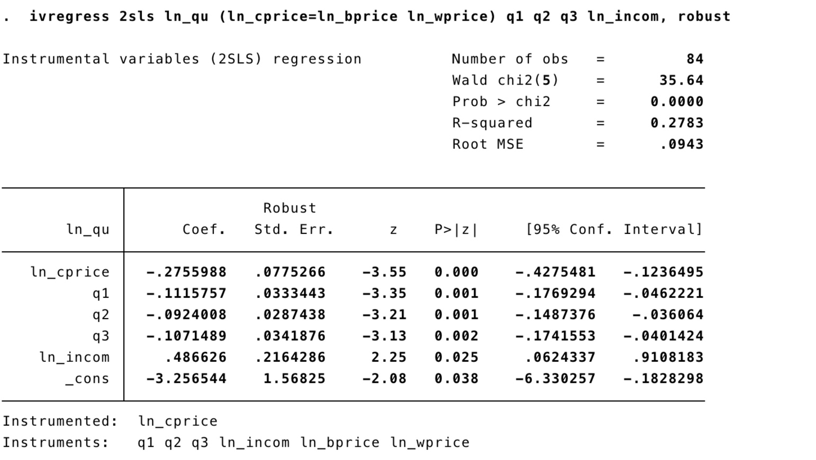***Robustness test for TSLS models**

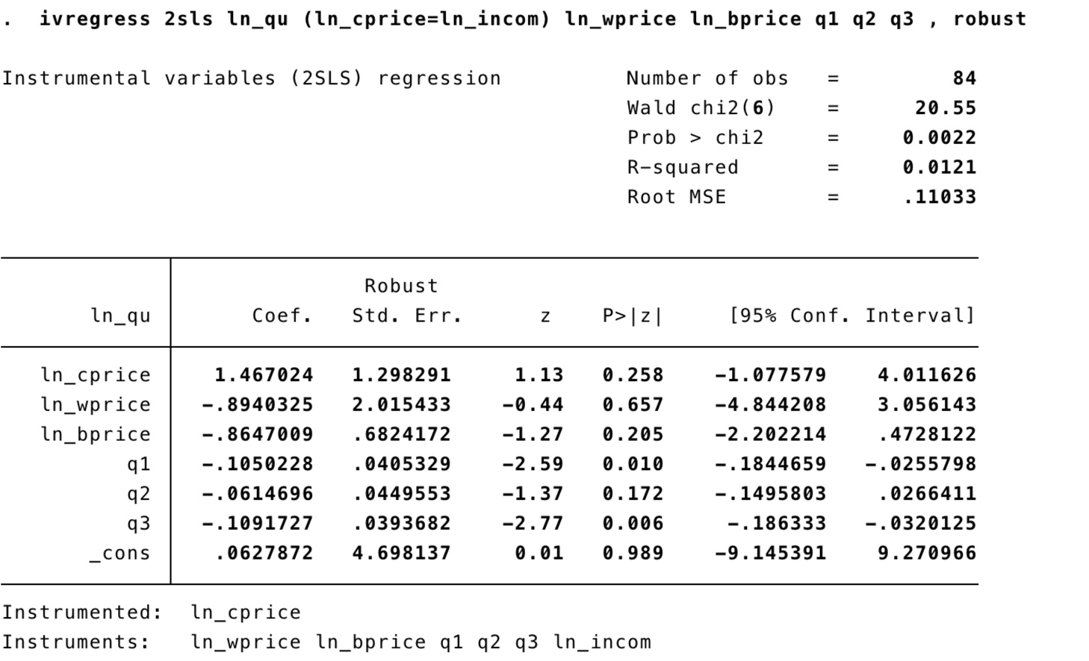 ***Figure B-1 Robustness test for TSLS demand model***

***Figure B-2 Robustness test for TSLS supply model***

### Appendix C

Control Variables for demand and supply functions:

|  |  |
| --- | --- |
| **Functions** | **Control Variables** |
| Demand | ln_incom, ln_tprice, q1, q2, q3 |
| Supply | ln_wprice, ln_bprice, q1, q2, q3 |

